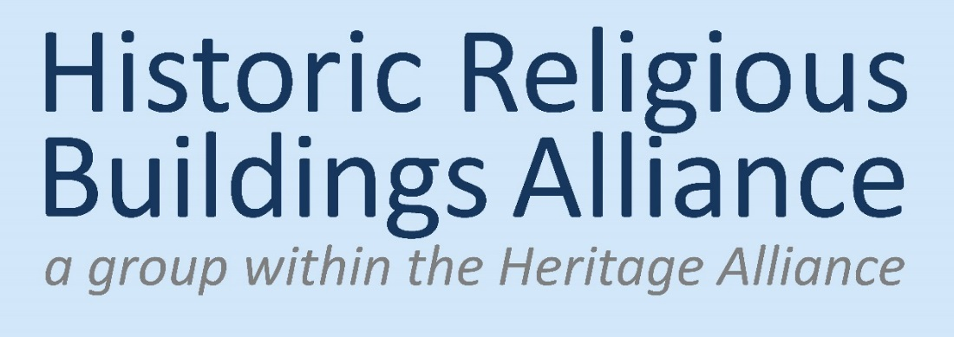
OUR YEAR
We bring together those working for a secure future for historic religious buildings

It is no secret that Covid-19 has put enormous pressure on some congregations, particularly those which were small in numbers to start with and had a substantial proportion of elderly people. Anecdotal evidence suggests that in a good many cases the numbers attending weekly worship has dropped by approximately one third, though this varies enormously.
This is bound to lead to further pressure on sustainability. This will make HRBA’s mission even more important – to bring together those working for a secure future for historic religious buildings.
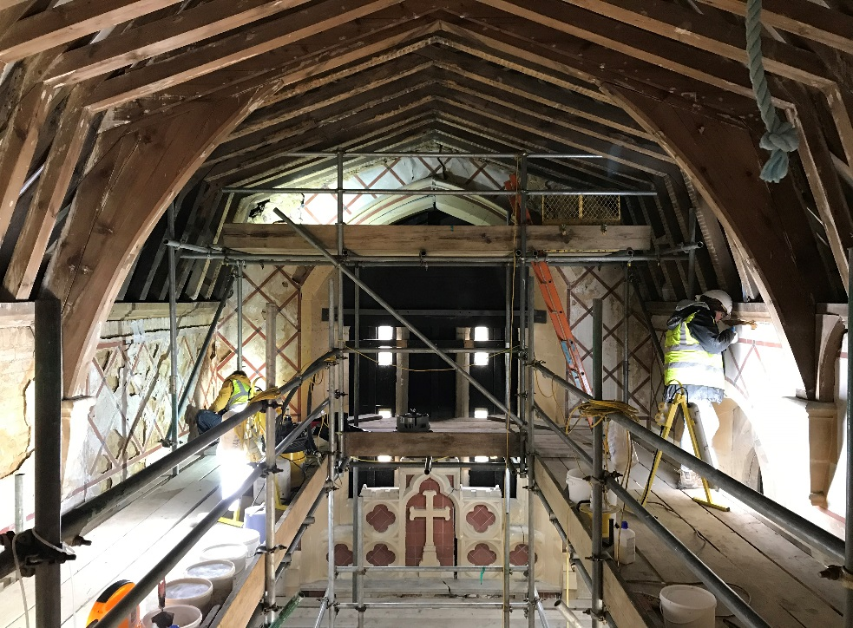
Despite these general difficulties, one recent encouragement has been DCMS announcing it would continue to fund until the end of March 2025 the Listed Places of Worship Grant Scheme, which allows congregations of listed buildings to recover the cost of VAT. HRBA sits on the Stakeholders Group for the Scheme, and we were delighted with this decision. The significant grants from the Culture Recovery Fund have also been extremely welcome.
As the pandemic has ebbed and flowed we have continued to produce our e-newsletter every month, reaching more than 1700 people, and to build our social media presence, with some 1150 followers on Twitter. During the pandemic we also began a new monthly series called Roving Reporter – ‘stimulating stories from those looking after historic religious buildings’ – which has ranged from articles about a gilded weathervane to a church journeying towards net zero.
We have continued our tri-monthly Members Briefing Meetings by Zoom. Cyberspace, has, of course, allowed participation from a wider geographical spread than our previous London-based meetings.
For all that, in December 2021 we did try to organise a face to face Briefing, but very regretfully had to cancel this and revert to Zoom – though as one of the speakers tested positive on the day itself then managed to find emergency online replacements at half an hour’s notice, this turned out to be a blessing in disguise. We are now thinking carefully about the way we should hold these meetings in future.
We held our annual Big Update by Zoom, in March 2021. The day had 25 separate segments, lots of videos, three computer models of church buildings being demonstrated in real-time, 20 participants from as far away as Norway, and four of us collaborating to operate the kit, backing each other up in case of drop out. The day was very well attended, and a great success, but did stretch our resources, and we are looking forward to an in-person event on 27 April 2022. (With bubbly and cake.)
ANNUAL REVIEW
for 2021

Distributed to members
March 2022
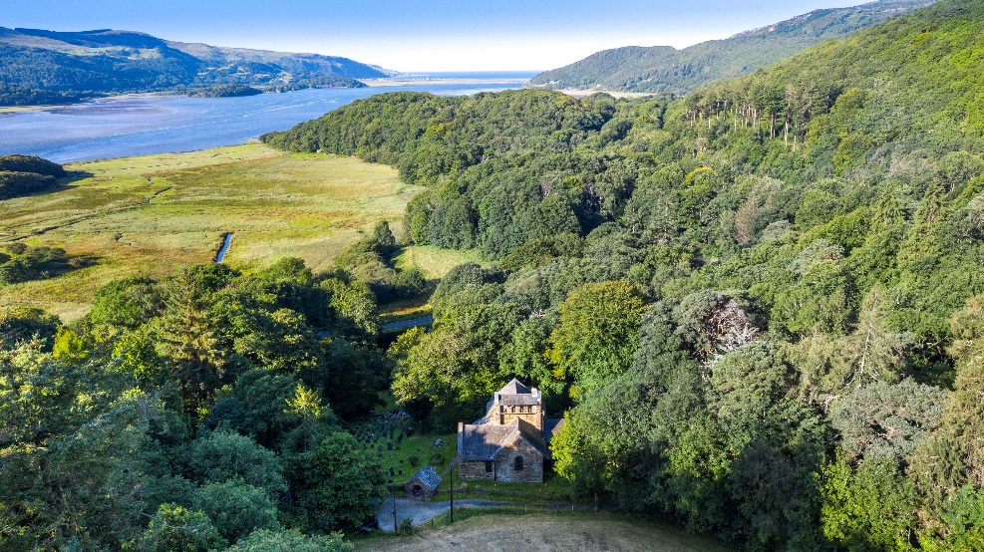
During the year we contributed to one relevant Government consultation, on the proposals for a new Duty to Protect from terrorist attacks. Along with others, we felt the proposals were disproportionate and their impact had not been thought through, and we are pleased that these concerns were acknowledged in the Government’s response document.
In 2021 and continuing into 2022 we have been working in partnership with two important research projects run by the Centre for Christianity and Culture at the University of York. One has been examining the impact of Covid-19 on places of worship (churchesandcovid.org). This led to a further initiative, exploring what information is needed by places of worship to help sustain them, and the best way of providing it. This includes enhancing the existing online knowledge portal, Crossing the Threshold (you can find the current version by googling).
Currently we have an in-house project to summarise the most important reports on the future of historic churches from the last decade. There is a great deal of information available: we hope to make it more accessible.
With this Review comes the annual subscription reminder. Our members – you – are vital to HRBA’s work, keeping those of us involved in its day to day activities in touch with what is happening, guiding our thinking, and giving us credibility when we speak to other bodies. We hope you will want to stay a member, part of the wider movement to ensure a secure future for historic religious buildings.

VOLUNTEERS
HRBA is run entirely by volunteers – ten of us at the moment, plus Trevor Cooper as Chair.
Keri Dearmer, joint newsletter editor
Charlotte Dodgeon, policy
Janice Gooch, social media
Lucy Jacob, joint newsletter editor
Johanna Louw, marketing
Donna McDonald, membership
Susan Miller, Roving Reporter
Becky Payne, development and operations
Eleanor Scott, one-off projects
Katherine Wallis, copyediting
During the course of the year, Diana Coulter finished a six year stint in the membership role – we are grateful for her work in this crucial job.

CORPORATE MEMBERS

(2021)
Allchurches Trust
Arthur Rank Centre
Association of English Cathedrals
ATS Heritage
Baptist Union
Berkshire Hist. Churches Trust
Buckinghamshire Hist. Churches Trust
Cathedral Communications Ltd
Catholic Church in England and Wales
Central Council of Church Bellringers
Centre for the Study of Christianity and Culture
Church Commissioners, Pastoral and Closed Churches
Church in Wales (Property Services Department)
Church of England, Cathedrals and Church Buildings Division
Church of Scotland (General Trustees)
Church Recording Society
Churches Conservation Trust
Churches Trust for Cumbria
Churches Trusts Forum
Churches Visitors and Tourism Assocn
CLAS (Churches’ Legislation Advisory Service)
Devon Hist. Churches Trust
Diocese of Ely
Diocese of Hereford
Diocese of London
Diocese of Norwich
Diocese of St Albans
EASA
Ecclesiastical Insurance Group
Ecclesiological Society
Friends of Friendless Churches
Historic Churches Scotland
Jewish Heritage UK
Maintain our Heritage
Methodist Church Connexional Team
National Churches Trust
Norfolk Churches Trust
Northamptonshire Hist. Churches Trust
Norwich Hist. Churches Trust
Oxfordshire Hist. Churches Trust
Pugin Society
Purcell
Scotland’s Churches Trust
Somerset Churches Trust
SPAB
Staffordshire Hist. Churches Trust
Suffolk Hist. Churches Trust
Twentieth Century Society
URC (United Reformed Church)
Victorian Society
War Memorials Trust
Yorkshire Synod, URC

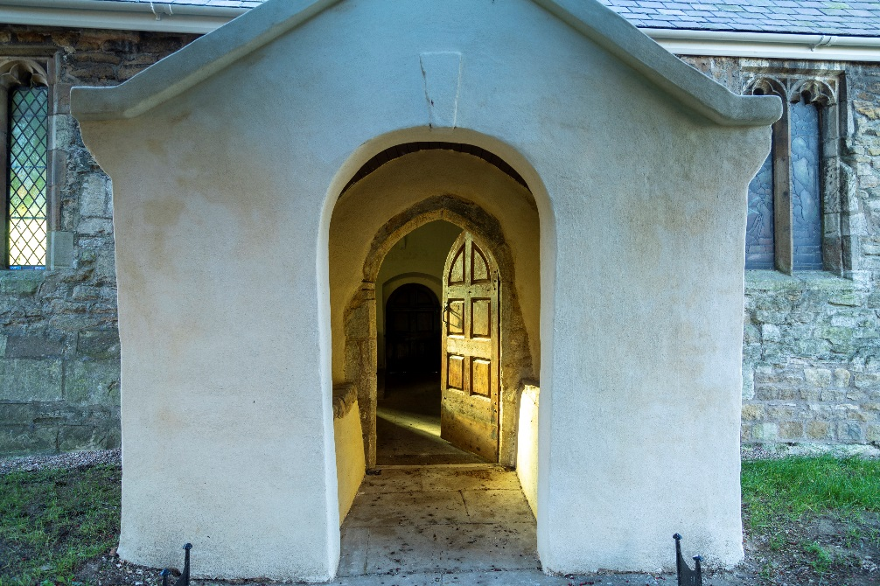
HRBA’S ROLE
We bring together those working for a secure future for historic religious buildings regardless of faith group or denomination.
We are the only group doing this across the UK.

Aims
Our aims are:
- To share information and best practice regarding historic religious buildings.
- Where appropriate, to act as a channel for communication with government.
- To act as midwife to projects involving more than one faith group or denomination.

Scope
Our scope is all listed places of worship in GB and NI, of whatever faith group or denomination.
In GB there are approximately 20,000 listed places of worship, of which about 60% belong to the Church of England (CofE). The CofE is supportive of the HRBA and is an active member.
Most other listed places of worship are churches belonging to the Church in Wales, the Church of Scotland, the Catholic Church, the Methodist Church, the Baptist Church and the United Reformed Church. The Churches Conservation Trust and the Friends of Friendless Churches also look after a substantial number. Other listed places of worship are looked after by other faith groups or smaller Christian denominations, or by dedicated Trusts.

Structure & Governance
HRBA is a self-financing part of the Heritage Alliance, reporting to the Chief Executive, Lizzie Glithero-West and through her to the Trustees.

HRBA HISTORY
The HRBA began life as an informal group meeting from time to time for discussion and update. Its existence was formalised in 2008/9 when it became part of what is now known as the Heritage Alliance.
At that time it started a quarterly newsletter to a small number of recipients.
Further changes came in 2011 when it set up a formal membership scheme for organisations and begun a free monthly e-newsletter available to all.
Further structural change came in 2012 when individual membership was made available. Since then it has developed and expanded its activities in various ways.

ROUTINE ACTIVITIES
Free monthly e-newsletter and Roving Reporter: The newsletter is well regarded and provides an important service to those engaged with historic religious buildings; sponsored by Luke Hughes & Co., it is now sent to more than 1,700 recipients.
They also receive the monthly Roving Reporter, which introduces people to stimulating ways in which historic religious buildings can used.
Social media: Our Twitter account alerts people to a very wide range of news.
Ad hoc briefings etc:
On an ad hoc basis we produce briefings and publications and circulate our members with updates on emerging topics. Occasionally these lead to projects being developed by one or more of our members.
Members Briefings: Every three months we organise a meeting for members, with speakers. These bring people up to date and encourage sharing of best practice.
Big Update: Once a year we organise an all-day meeting, The Big Update, with a range of speakers that is open to members and non-members.
Consultations: We respond from time to time to government initiatives where appropriate. We are members of the LPWGS stakeholders’’ group.

SUBSCRIPTIONS

SUBSCRIPTIONS: PAYMENT OPTIONS
Your invoice for the 2022 subscription will be emailed to you (covering one year from April 2022).
Please pay either by PayPal (following the instructions on the invoice) or by BACS. If by BACS, please let us know that payment will be made this way and give reference: ‘HRBA’ and invoice number. BACS payments details are: Bank Address: CAF Banks Ltd, 25 Kings Hill, West Malling, Kent ME19 4JQ. Account name: The Heritage Alliance. Sort Code: 40 52 40 Account Number: 00013268
In case of difficulty, please contact Donna McDonald at email: hrbmember @theheritagealliance.org.uk
We hope you will continue to support us, not least as a vote of confidence in what we are attempting to do.
We are run entirely by volunteers, so there are no employment costs. Subscriptions help to pay for travel expenses, general running costs, special projects, and accommodation and infrastructure services (kindly provided by The Heritage Alliance).
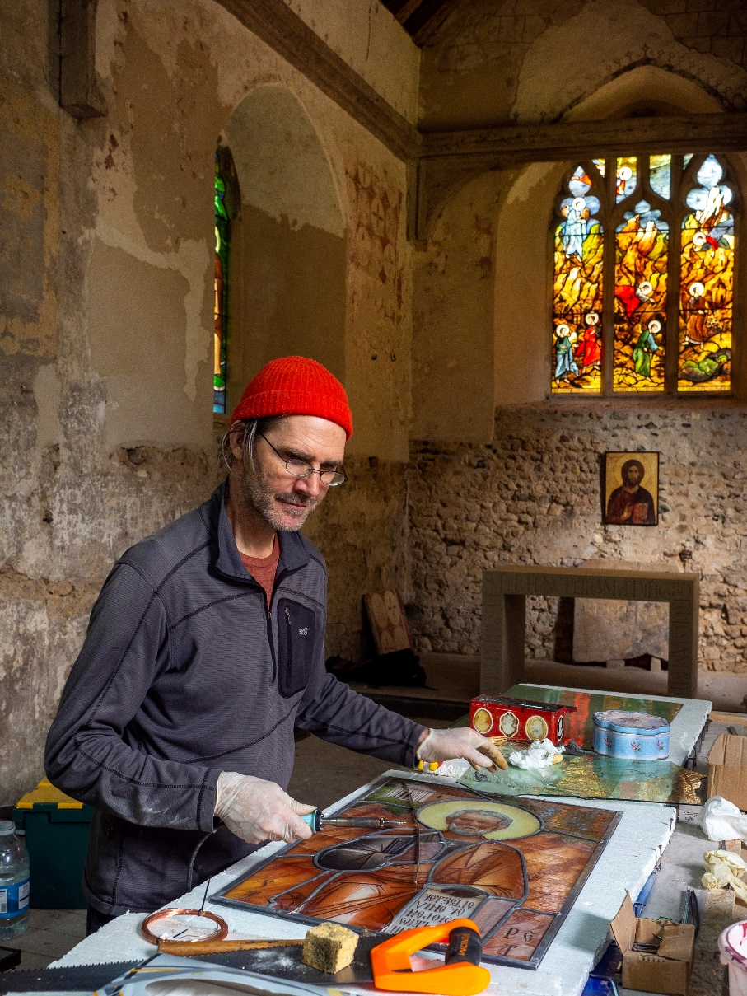
Please note we will acknowledge corporate membership on our website, unless you tell us otherwise.
Sole Traders, who pay a higher subscription than Individual Members, benefit from being able to publish on the HRBA website their contact details, a website link, and information about their activities (up to a maximum of fifty words).
The Historic Religious Buildings Alliance
Postal address: currently (March 2022) we are moving offices from Lavington Street. Please email us before sending
anything through the post.

Email: hrb@theheritagealliance.org.uk
Twitter: @hrballiance
Web: www.hrballiance.org.uk

ILLUSTRATIONS
Illustrations were kindly provided by our member, the Friends of Friendless Churches (FoFC).
Page 1: St Denis, East Hatley, Cambs – plaster conservation underway
Page 2: St Philips, Caerdeon, Gwynedd; received by FoFC March 2021
Page 3: St Helens, Barmby on the Marsh, Yorkshire – received by FoFC 2020, £280k repairs from Culture Recovery Fund
Page 4: St Peters, Wickham Bishops, Essex – making new windows © Adrian Powter
If your organisation would like to contribute a set of photos next year, please let us know.

